

nRF9151 DK
Development kit for LTE-M/NB-IoT/GNSS/DECT NR+


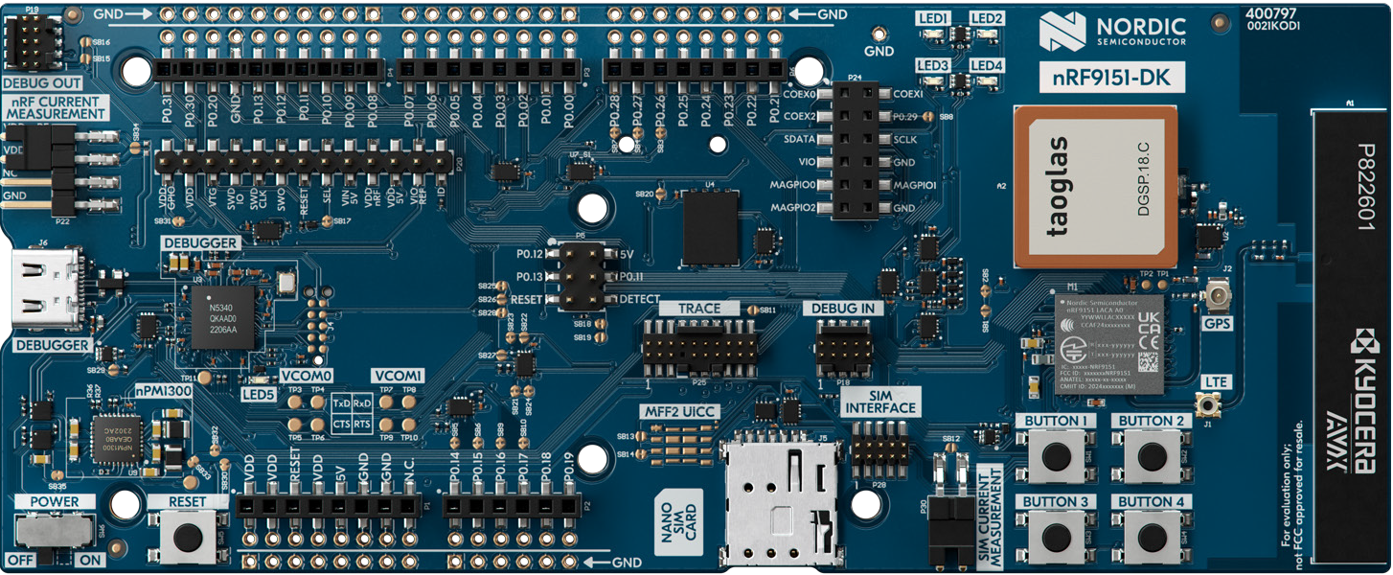
Key features
• Same certification coverage as nRF9151 SiP
• LTE-M/NB-IoT & GNSS antennas with
respective SWF RF connectors
• SEGGER J-Link OB programmer/debugger
• Pins for measuring power consumption, e.g. with Nordic's Power Profiler Kit II
• User-programmable LEDs & buttons
• 3.0-5.5 V supply from external or 5 V Supply from USB

• Bundled with SIM cards from Velocity IoT(VIOT-1SIM) preloaded with Each SIM includes a free 100MB data allowance, shown as a $5.70 discount. Charges apply only after exceeding this amount. The discount is valid for 3 billing cycles before expiring.


Product overview
The nRF9151 DK is an affordable, pre-certified single board development kit for evaluation and development on the nRF9151 System-in-Package (SiP) for LTE-M, NB-IoT, GNSS and DECT NR+. It has a dedicated LTE-M, NB-IoT and DECT NR+ antenna that supports a wide range of bands to operate globally. The nRF9151 DK has the same coverage as the nRF9151 SiP. LTE bands B1-B5, B8, B12, B13, B17-B20, B25, B26, B28, B65, B66 and B85 are supported.

An integrated patch antenna for GNSS is also included on the PCB, while SWF RF connectors are available for measuring the performance of the RF signals. Both antenna connectors also allow for the use of
external antennas.

All GPIOs and interfaces are available via connectors. The kit is Arduino Uno Rev3 compatible, meaning it can easily interface with external device shields. User-programmable LEDs and buttons (4 each) are available for output
and input.

The nRF9151 DK has both a nano/4FF SIM card slot and an MFF2 SIM footprint, to support plug-in and soldered (e)SIMs. The kit is shipped with SIM cards from Onomondo and Wireless Logic preloaded with free data. It also supports the use of Software SIM.

Programming and debugging are enabled through the on-board SEGGER J-Link, which also supports programming and debugging external targets.

The nRF9151 DK is supported by a full suite of development software, tools and resources, including the Nordic Developer Academy’s Cellular IoT Fundamentals course.

The nRF9151 DK comes pre-flashed with our Serial LTE Modem application for interfacing through AT Commands. Getting started with other firmware samples is available in the Quick Start tool, found in nRF Connect
for Desktop.

f
nRF9151 SiP
• Fully integrated SiP with 64 MHz Arm Cortex-M33 and multimode LTE-M/NB-IoT modem with DECT NR+ support and GNSS
• 700-2200 MHz LTE band support
• Power Class 5 20 dBm
• Power Class 3 23 dBm
• 1.9GHz NR+ band support
• Certified for global operation
• Dedicated programmable application processor and memory
• 1 MB flash + 256 KB RAM
• Arm TrustZone + Arm CryptoCell 310

Velocity IoT SIM
- Triple-cut (2FF/3FF/4FF) SIM card
- Multi-Network connectivity with access to over 600 carriers including major US providers.
- Global Connectivity with minimal latency
- Remote SIM Management
- Real-Time Insights

Applications
• Asset Tracking
• Smart Metering
• Smart City
• Smart Agriculture
• Predictive maintenance
• Portable Medical Devices
• Industry 4.0

nRF9151 DK Product Brief Version 1.1

For more in ormation please visit: nordicsemi.com/9151DK

